**Simple Calculator Microservice Documentation**

* **Link to the GitHub repository:** [**https://github.com/iduwaradp/sit323-2025-prac4p.git**](https://github.com/iduwaradp/sit323-2025-prac4p.git)

**1. Introduction**

The microservice performs basic arithmetic operations such as addition, subtraction, multiplication, and division.

**2. Prerequisites**

Before starting, ensure you have the following tools installed:

* Node.js
* Visual Studio Code
* Git

**3. Step-by-Step Guide**

**Step 1: Set Up the Project**

* Open Visual Studio Code.
* Create a new folder named calculator-microservice.
* Open the git bash and navigate to the folder:
  + - cd calculator-microservice
* Initialize a new Node.js project:
  + - npm init -y

**Step 2: Install Dependencies**

* Install Express.js by running the following command:
  + - npm install express

**Step 3: Create the Microservice Code**

Inside the calculator-microservice folder, create a file named server.js.

* Open server.js and add the following code:

const express = require('express');

const app = express();

//  parse JSON requests

app.use(express.json());

// Function to handle calculations

const calculate = (req, res, operation) => {

    const num1 = parseFloat(req.query.num1);

    const num2 = parseFloat(req.query.num2);

    if (isNaN(num1) || isNaN(num2)) {

        return res.status(400).json({ error: 'Please provide valid numbers.' });// error correction output

    }

    // opration selection

    let result;

    switch (operation) {

        case 'add': result = num1 + num2; break;

        case 'subtract': result = num1 - num2; break;

        case 'multiply': result = num1 * num2; break;

        case 'divide':

            if (num2 === 0) {

                return res.status(400).json({ error: 'Cannot divide by zero.' });// error correction output

            }

            result = num1 / num2;

            break;

    }

    res.json({ result });

};

// API routes user need

app.get('/add', (req, res) => calculate(req, res, 'add'));

app.get('/subtract', (req, res) => calculate(req, res, 'subtract'));

app.get('/multiply', (req, res) => calculate(req, res, 'multiply'));

app.get('/divide', (req, res) => calculate(req, res, 'divide'));

// Start server mode

const PORT = 3000;

app.listen(PORT, () => console.log(`calculator microservice running on port ${PORT}`));

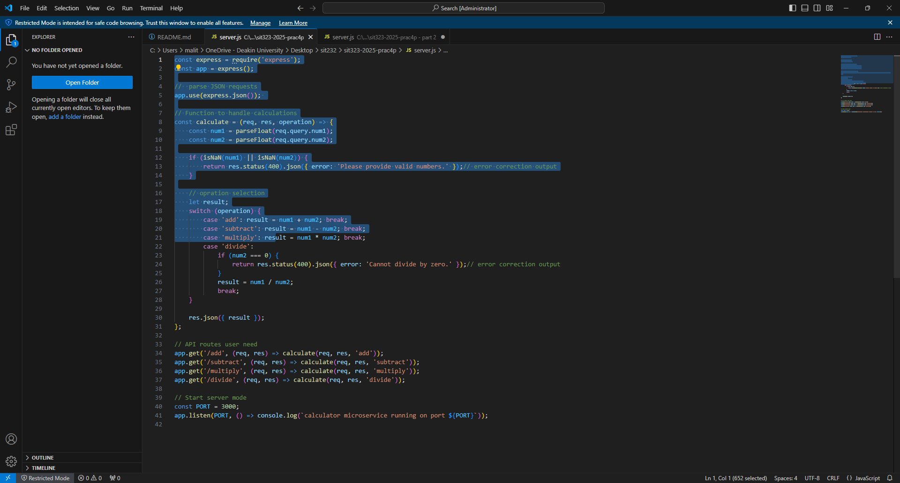

**Step 4: Run the Microservice**

* Start the microservice using the following command:
  + - node server.js

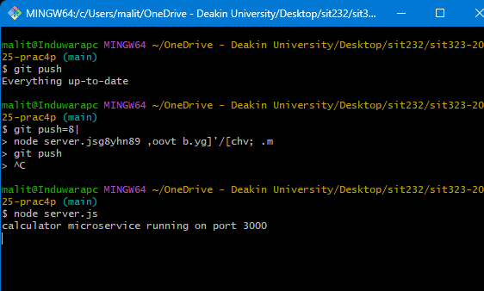

**Step 5: Test the Microservice**

* Open a browser and test the following URLs:
  + - Addition: <http://localhost:3000/add?num1=10&num2=5\>
    - Subtraction: <http://localhost:3000/subtract?num1=10&num2=5>
    - Multiplication: <http://localhost:3000/multiply?num1=10&num2=>5
    - Division: <http://localhost:3000/divide?num1=10&num2=5>

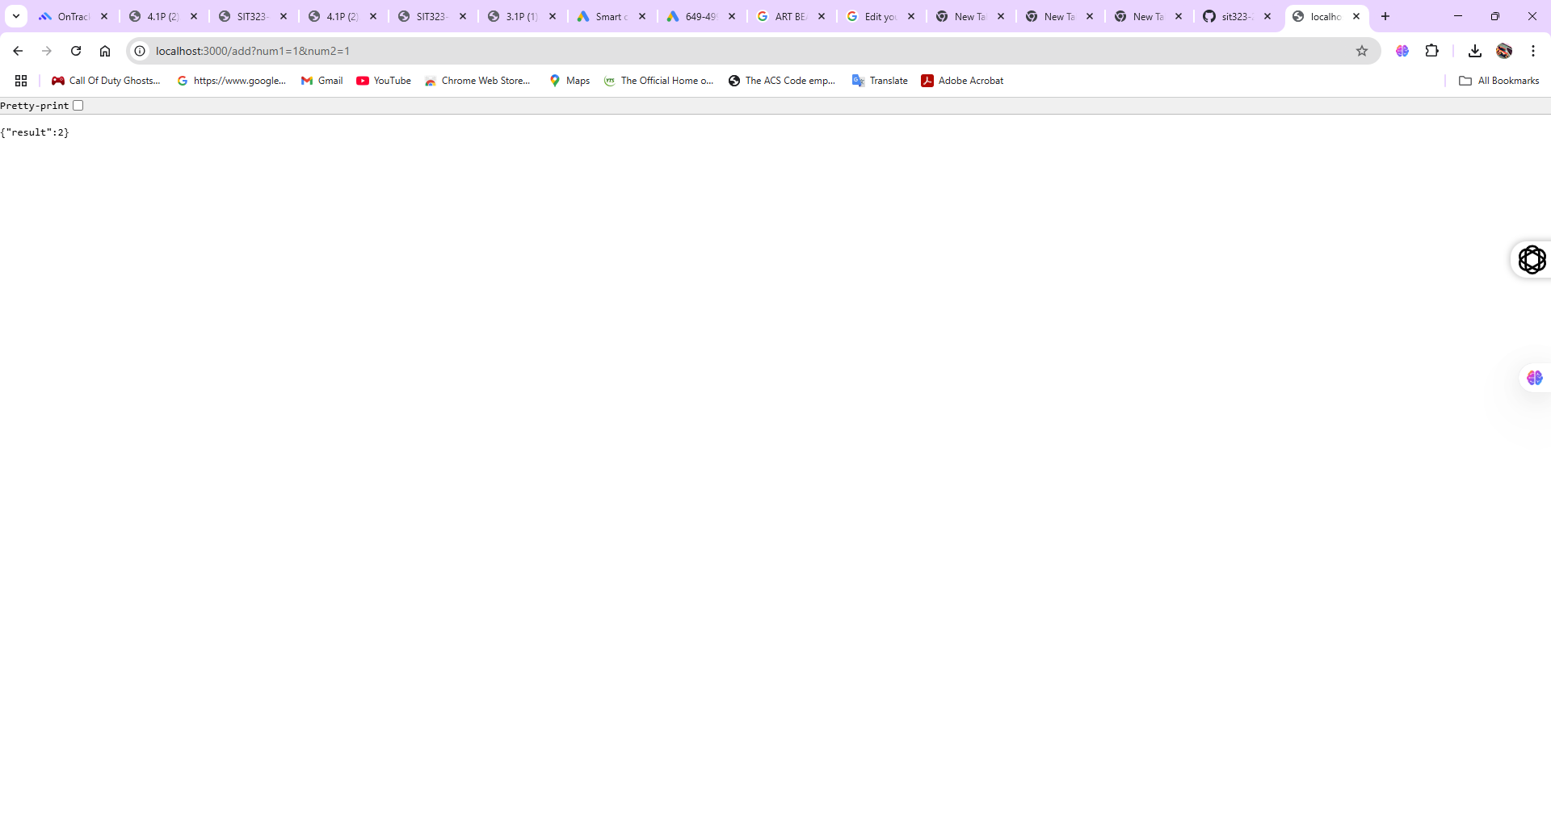I added num1=10 and num2= 5 You can change the values on num1 and num2 as input of the calculation.

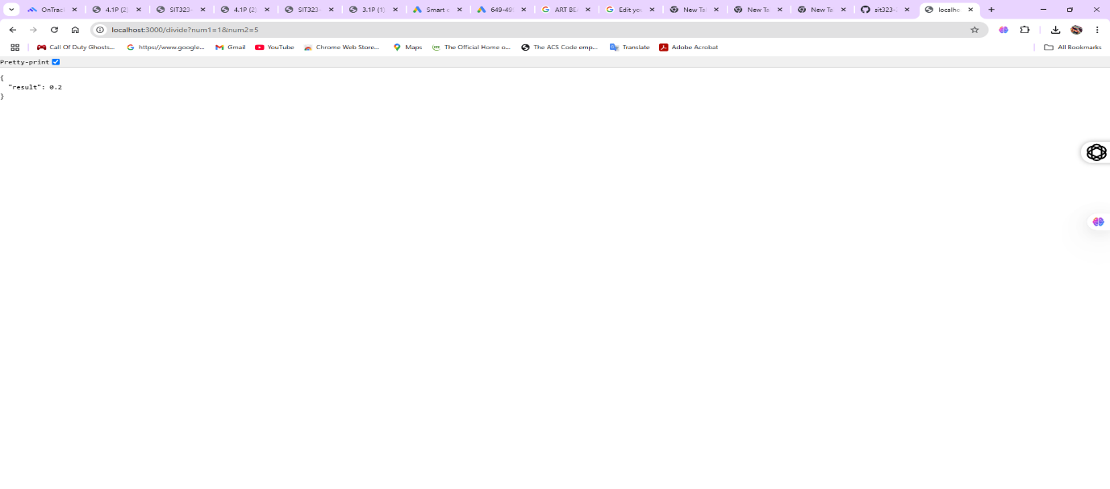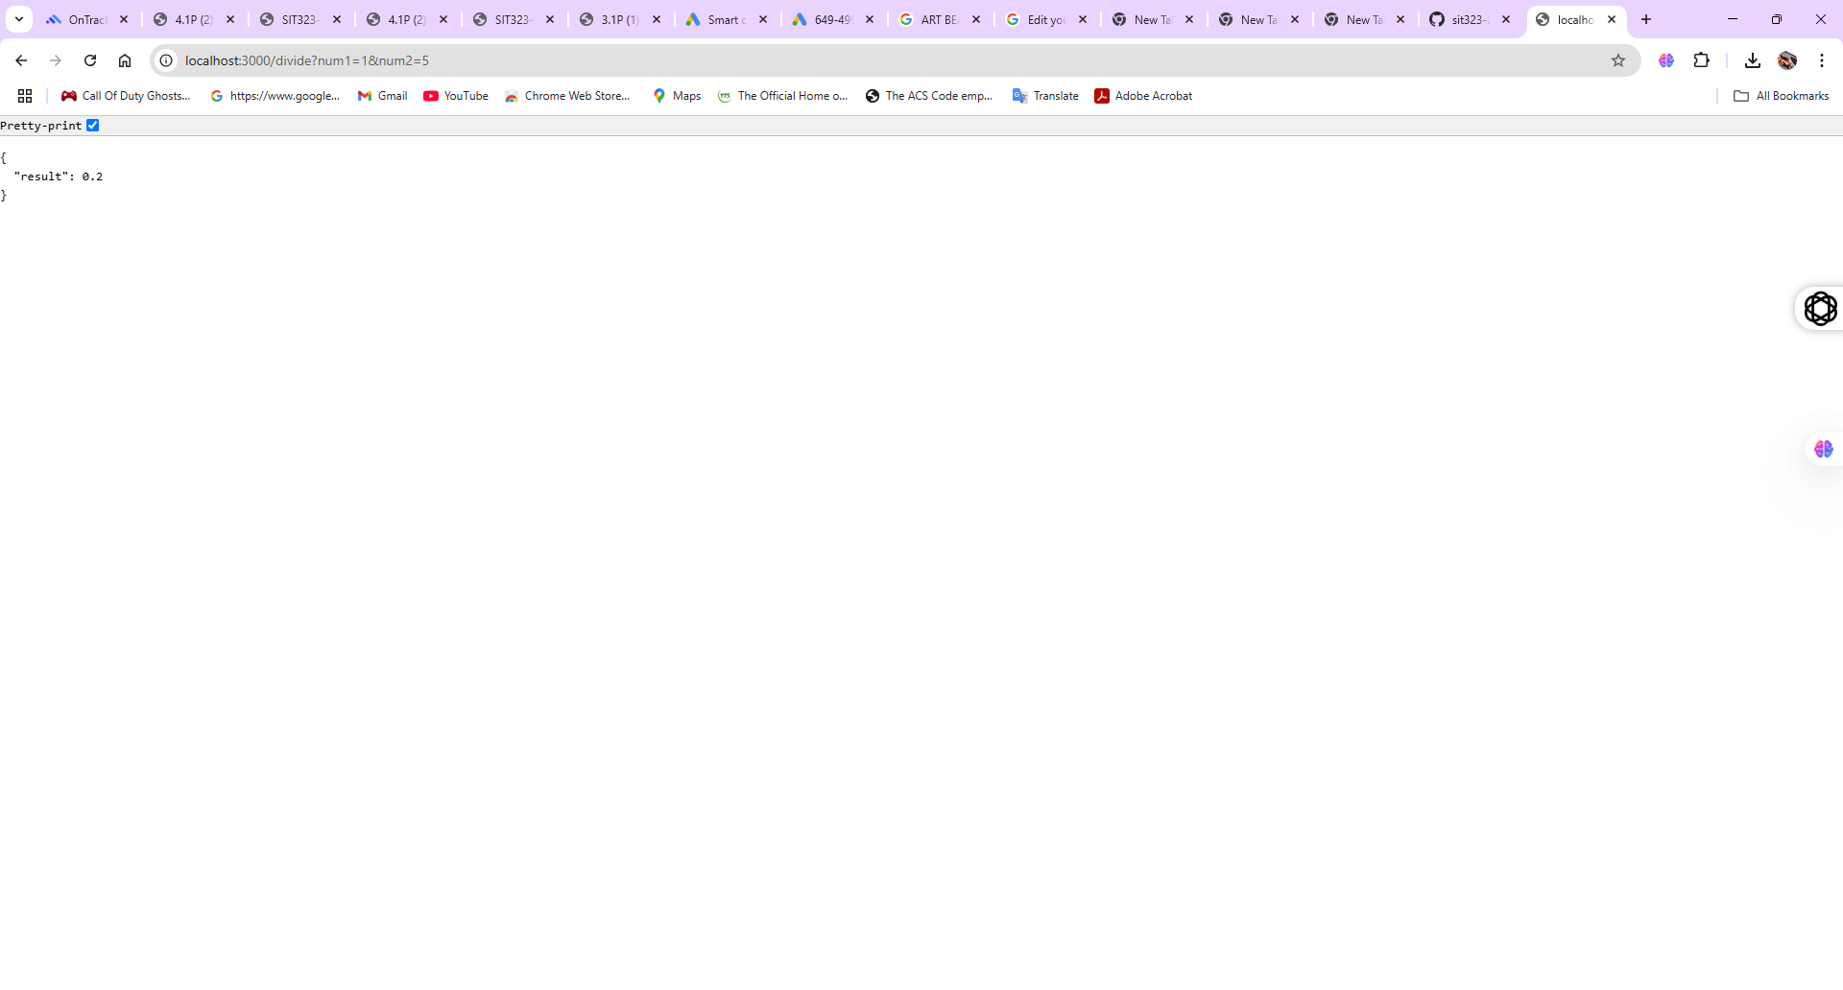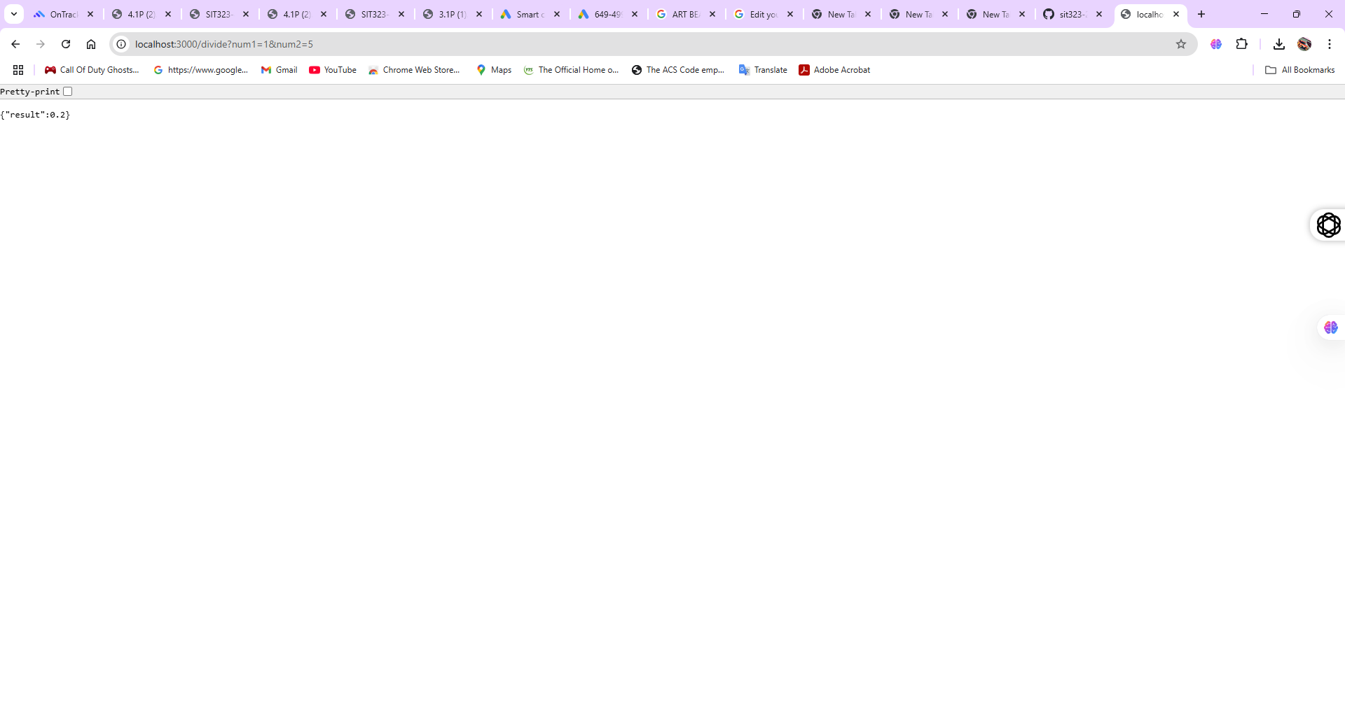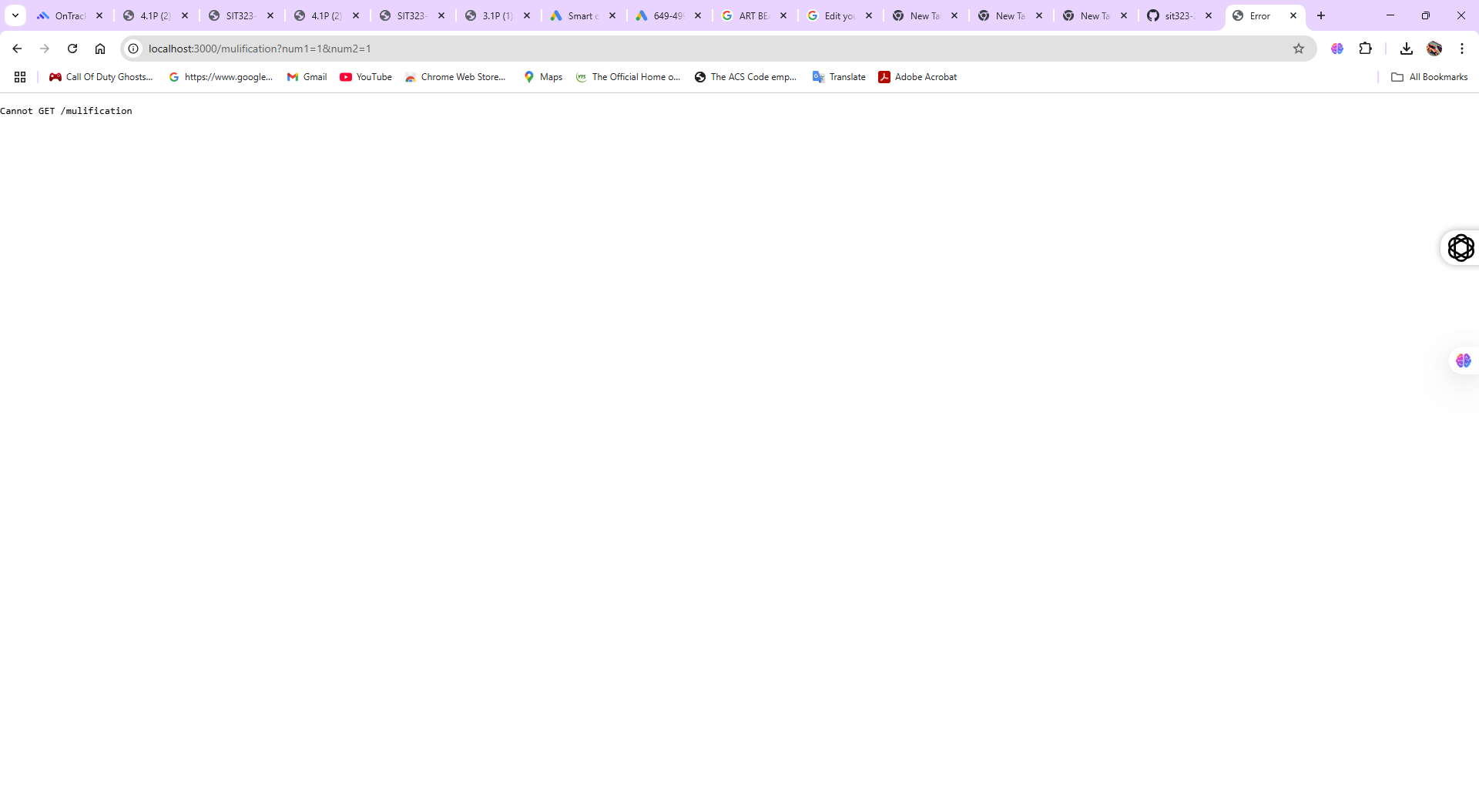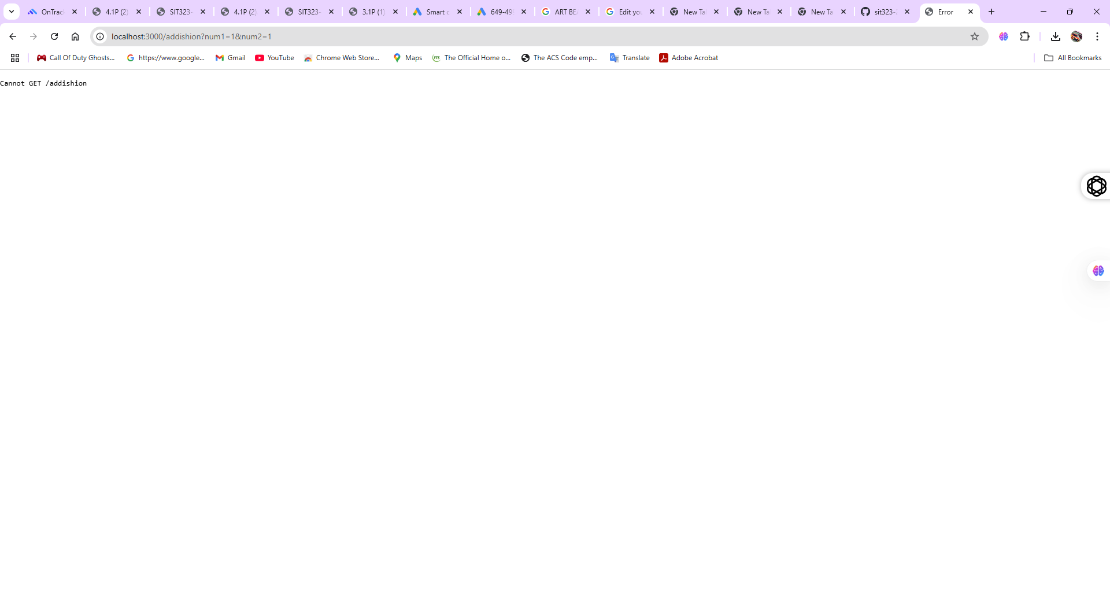

**4. GitHub Repository**

**Step 1: Initialize Git and Push Code**

* Initialize a Git repository:
  + - git init
    - git add .
    - git commit -m "Initial commit - Calculator microservice"
* Create a new GitHub repository named sit323-2025-prac4p.
* Push the code to GitHub:
  + - it remote add origin https://github.com/your-username/sit323-2025-prac4p.git
    - git branch -M main
    - git push -u origin main

